Exclusive Study of REALME Phone’s.

Rima is thinking of buying a new phone, let’s help Rima choose the best. She prefers Realme model’s for having it used previously.

She’s pretty confused and comes up to Rajnandni for help.

Rajnandni briefly asks her for her needs and this is what she says!

1. Good Processor
2. Battery
3. Enough Storage to accommodate all your gallery pictures, Right?
4. Good camera at reasonably affordable price that makes your portraits super duper!
5. Customer Reviews!!!!

Let’s dive in!! 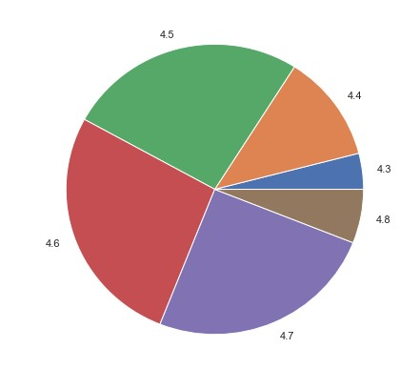Customer rating is something that plays a vital role in choosing your brand and set for we humans have a tendency to believe more on what other’s use than taking risks to new models. Strange but yes, it’s a undeniable fact.

The above pie chart suggests the customers have rated this brand product as very good with a rating between 4.3 to 4.8.

Out of 150 model’s of the same brand product,

1. 4.3 = 4%
2. 4.4=12%
3. 4.5 =25%
4. 4.6 = 26%
5. 4.7 =27%
6. 4.8= 6%

So, Rima thums up for you’ve chosen the right brand!

Price you pay for the product plays huge importance. It’s dependencies are reflected on it’s internal and external configurations.

The below correlation matrix that we consider with respect to price give’s us a succinct depencies to a greator extent on which of the underlying factors.

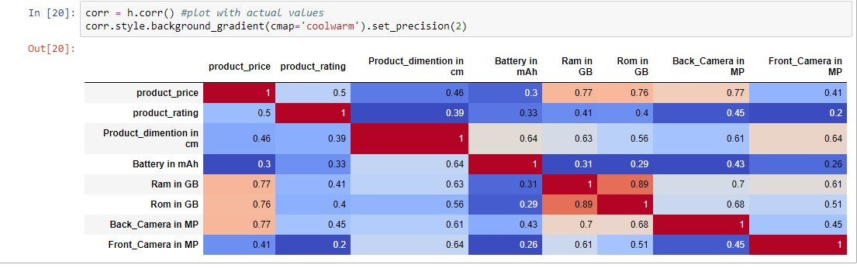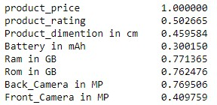

We observe that the dependency is well reflected to be positive and The RAM, ROM, CAMERA,BATTERY,Rating are all positively correlated.

So, the price you pay for your product is the congregation of all ofthesefeatures.

Now let’s have a look at the processor that Realme phones have!

You’ll be surprised to know there are 18 processor which hugely effects the price of the phone. Yes, processor is certainly an important aspect for The **processor** of your smartphone **is** the component that converts all your actions into visual changes on the screen.

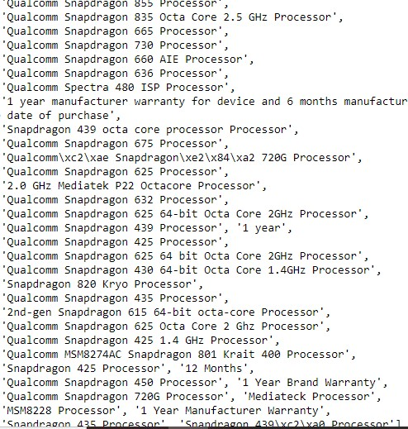

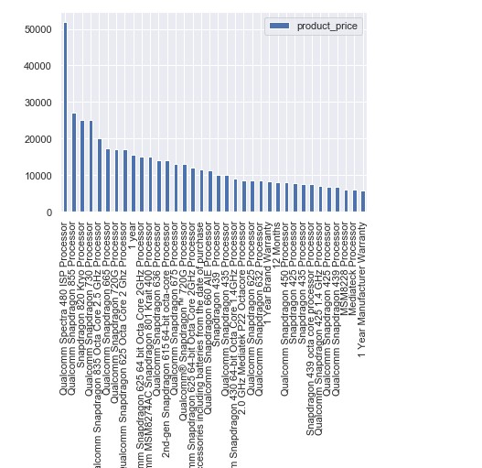

This bar graph show’s how the price variates with the processor class. But the processor should also be in inline with the rating for it then proves its working pace to be good and visual conversion to be more accurate .

 The **processor** is the engine that works its way and it utilizes the resources it has. Thus, the amount of **RAM** directly affects the performance of a device. On the other hand, a slow **processor** with a huge 2GB of **RAM** will also not work out just right. It should be a sweet combination of the two

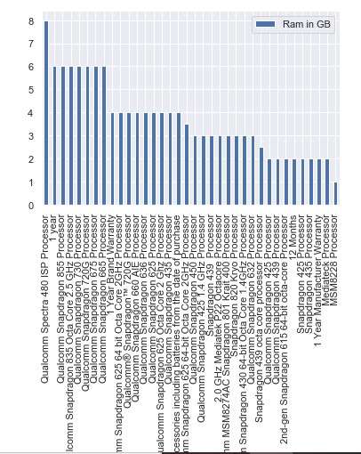

Some of the processor’s that’s considered a good buy are inline with theRAM.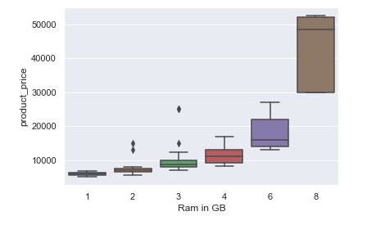

The Ram should be at the same time well priced and well rated and even according to our budget.

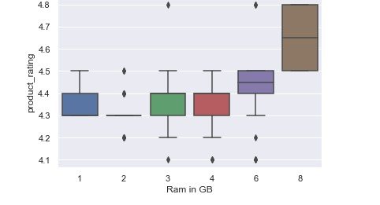

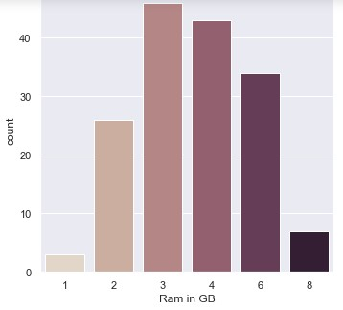

Therefore observed,

1. Phones ranging with 3-4 GB RAM have a pretty decent rating of 4.3 to 4.5 and price labeled between 7,500 to 20,000.
2. This is the range at which the ratings are highly populated with a percentage of 25,26 and very few phones rated at 4.3 in the lower ranges.
3. The following processors that fit best with the RAM, THE PRICE, THE RATING are as follows.

1.Qualcomm Snapdragon 625-Octa Core -2 2 GHZ Processor

2. Qualcomm Snapdragon 435 Processor

3. Qualcomm Snapdragon 655 Octa-Core -2GHZ

4. Qualcomm Snapdragon 636 processor AIE

5.Qualcomm Snapdragon 660 AIE processor

6. Qualcomm 625 64 Octa Core 2 GHz Processor

7. Qualcomm Snapdragon 665 Processor

8. Qualcomm 675 Processor

9. Qualcomm 720 GHz Processor

Considering other feature’s like camera,battery, dimention’s lets choose the best pick model in a budget that meets our needs!

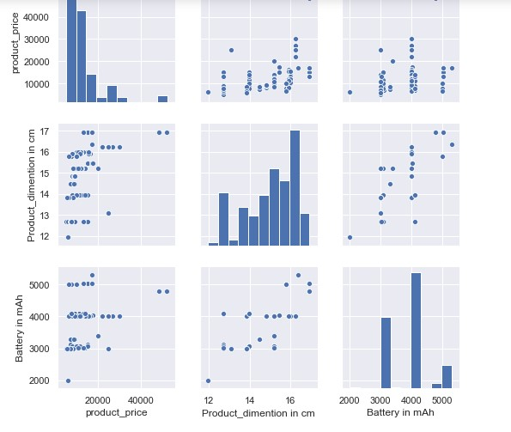

Battery, ProductDim are certainly deciding factors when it comes to price. The above pairplot shows a positively skewed matrix rep.

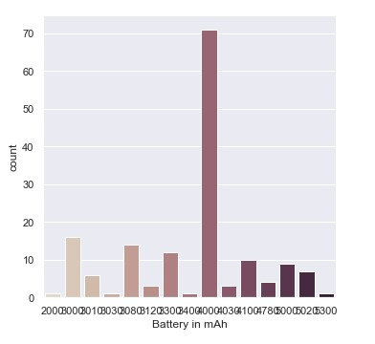

The battery with 4000 mAh has greatest frequency.

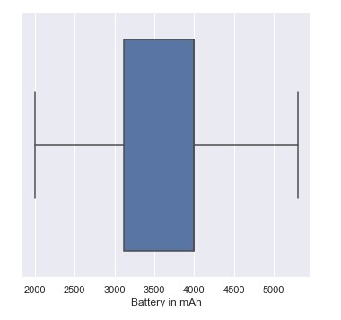

This is the range of the Battery in mAh with

1. minimum being 2000mah
2. max being 5000mah
3. upper and lower quartiles being 4000mah and 3100 mah

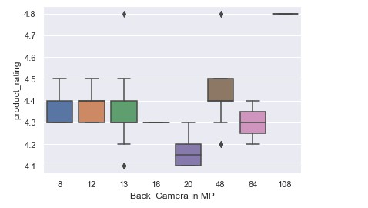

1. The product is equi- rated for for cameras with 8mp,12mp back camera.
2. Whereas the one with with 13mp are rated with a range of min value of 4.2, max of 4.5, upper and lower quartiles as 4.3, 4.4.
3. The one’s with 20mp is rated with 4.1 to a maximum of 4.4.
4. The one with 48mp is rated with a max rating of 4.5 and min of 4.3 which is fairly good.
5. The one with 64 mp is rated with min rating of 4.2 and 4.5 as maximum rating.

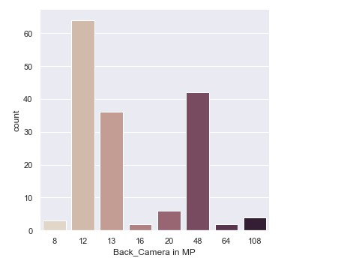

The 12mp back camera, following the 48mp, which in turn follows the 13mp cameras have counts of over 60, 42, and 36 respectively.

Considering the ratings let’s have a look at what price we pay for it?

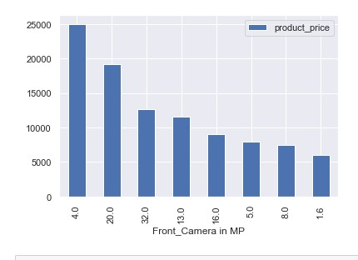

The price’s for the front camera is evident with the following graph that says-

1. For options under 10000Rs, we can go for compromising a bit on the quality of camera’s with 1.6,8.0,5.0,16.0 mp.
2. Considering the budget of 10000 to 20000, we have a range of options without much compromisation on the quality with 13mp,32mp,20mp

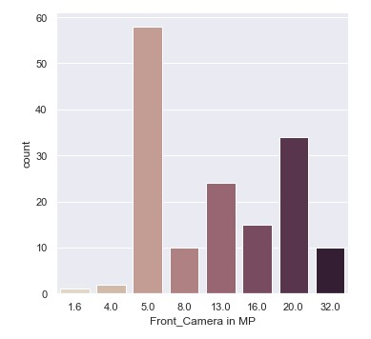

1. 5mp camera’s with the highest count in phones over 50 for its affordability, following the 20mp with around 35 counts, following the 13mp camera’s over 20.

Having considered all the features, now let’s have a look at the price.

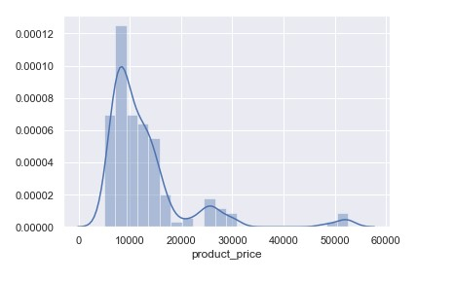

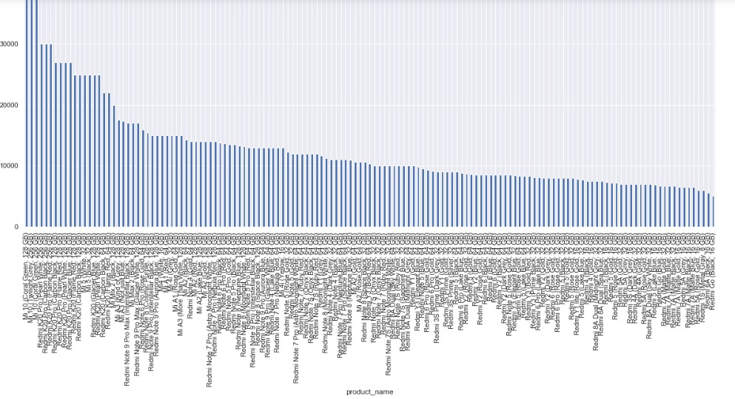

This above plot clearly describes how the product price ranges, with the product name’s.

We infer a majority of the models are under 10000Rs,whereas relatively higher between 10000 to 20000 meeting most of the feature needs, and then above 20000 is really less populated with least options available.

Models Ranging between 10000RS to 20000RS.



The



The models ranging below 10000Rs satisfying most of the features.

Feature Importance 